CS 255 System Design Document Template

This template lays out all the different sections that you need to complete for Project Two. Each section has guidance to prompt your thinking. You will need to continually reference the interview transcript as you work to make sure that you are addressing your client’s needs. There is no required length for the final document. Instead the goal is to complete each section based on what your client’s needs are. Remove this note when you are finished, and replace all bracketed text with the relevant information.

UML Diagrams

UML Use Case Diagram
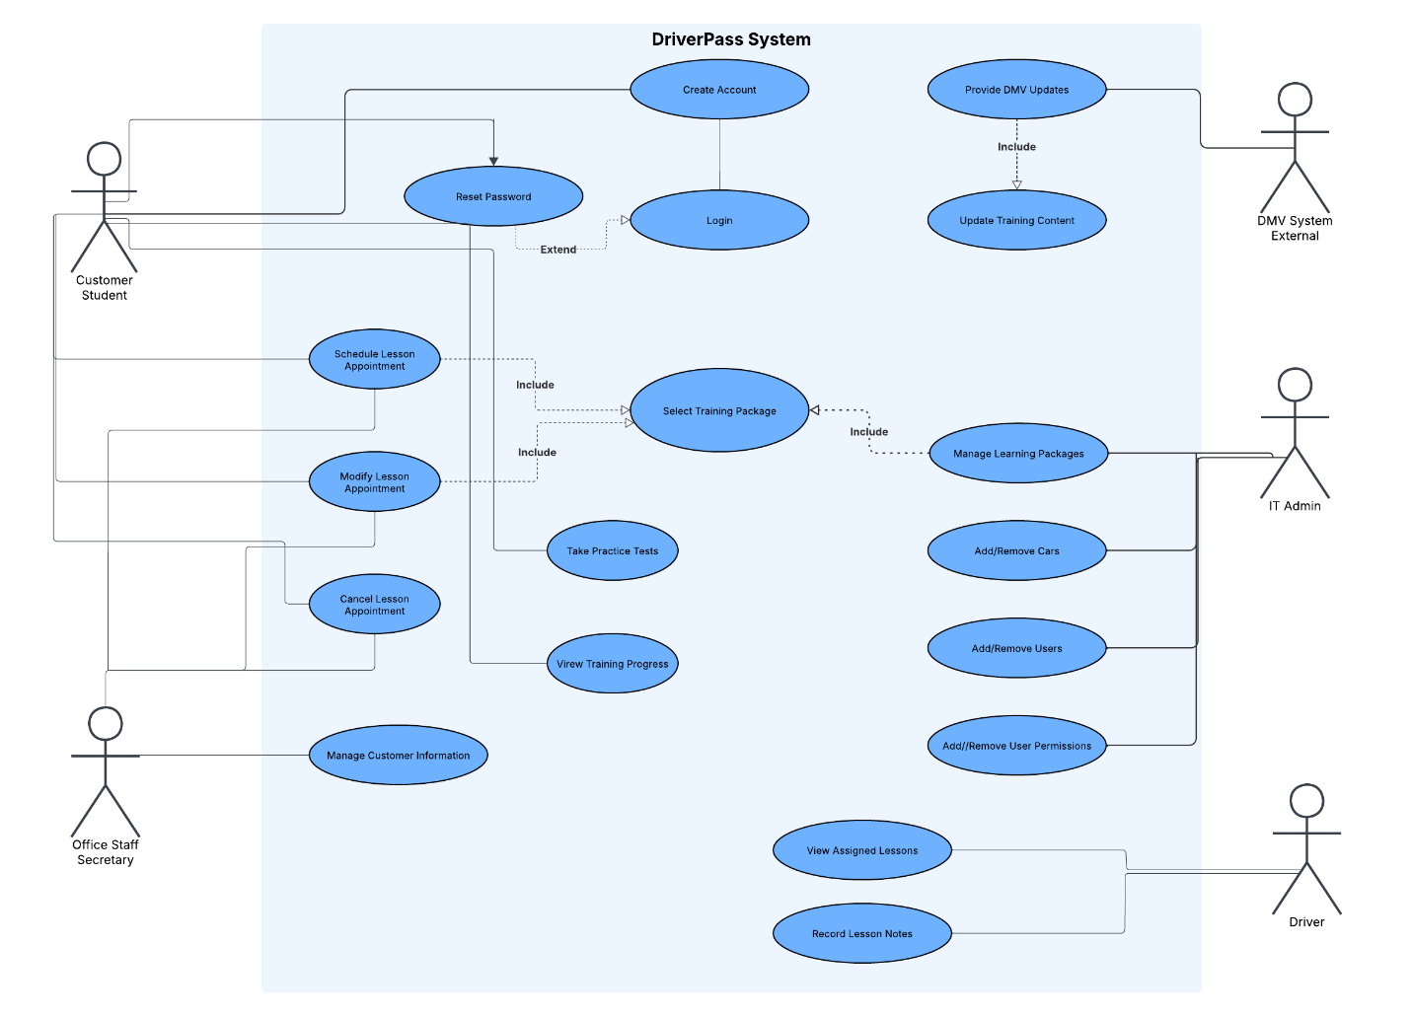

UML Activity Diagrams

This UML activity diagram represents the process a customer follows to schedule a lesson appointment in the DriverPass system, including selecting a training package, choosing an available date and time, validating availability, and confirming the scheduled lesson.
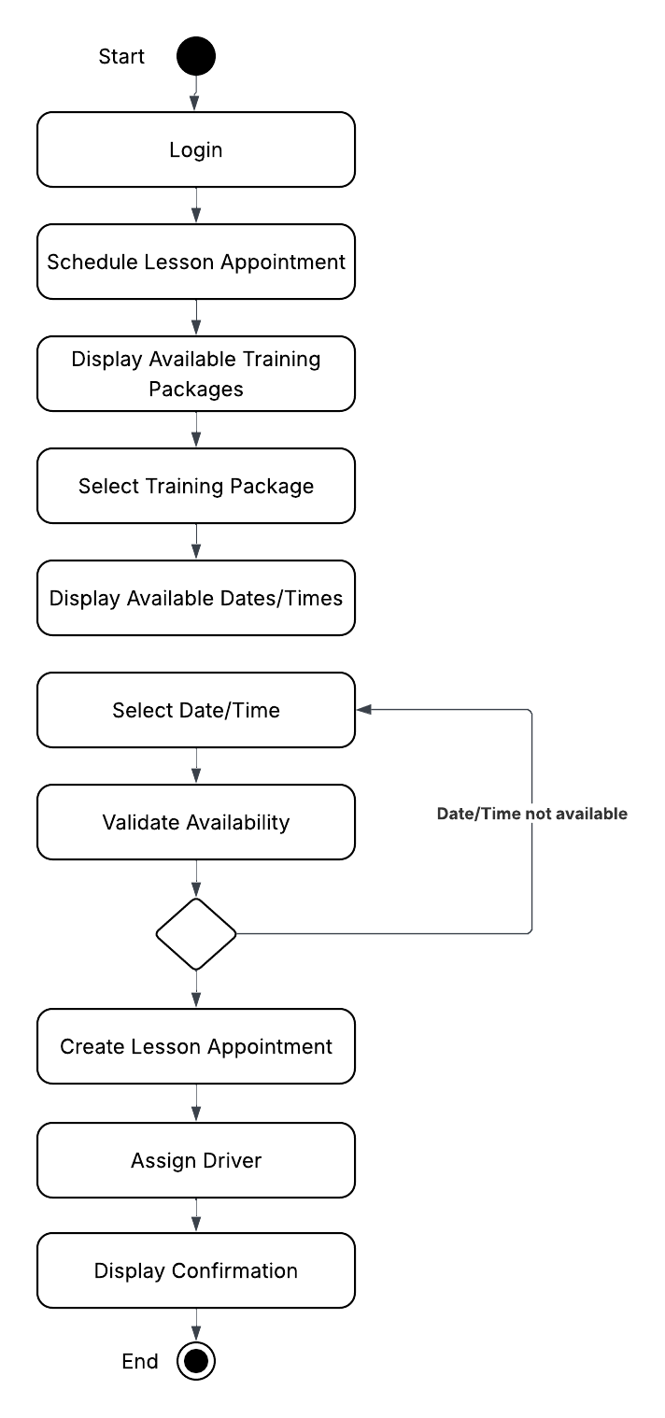

This UML activity diagram represents the process an IT Admin follows to manage learning packages in the DriverPass system, including adding new packages, editing existing packages, validating package information, deleting packages, and displaying the updated package list.

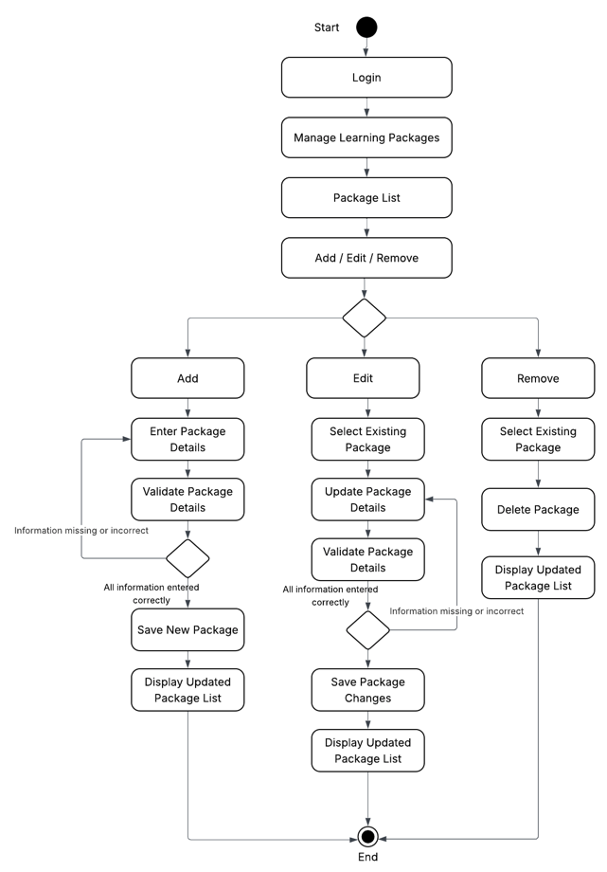

UML Sequence Diagram
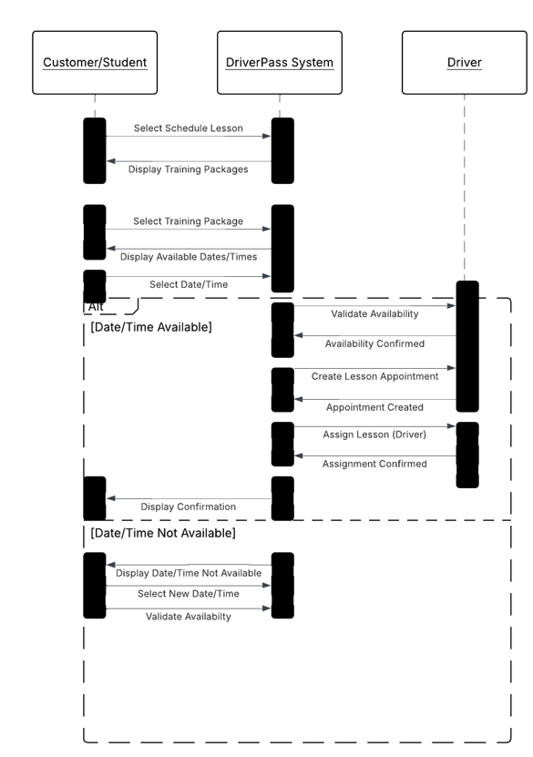

UML Class Diagram
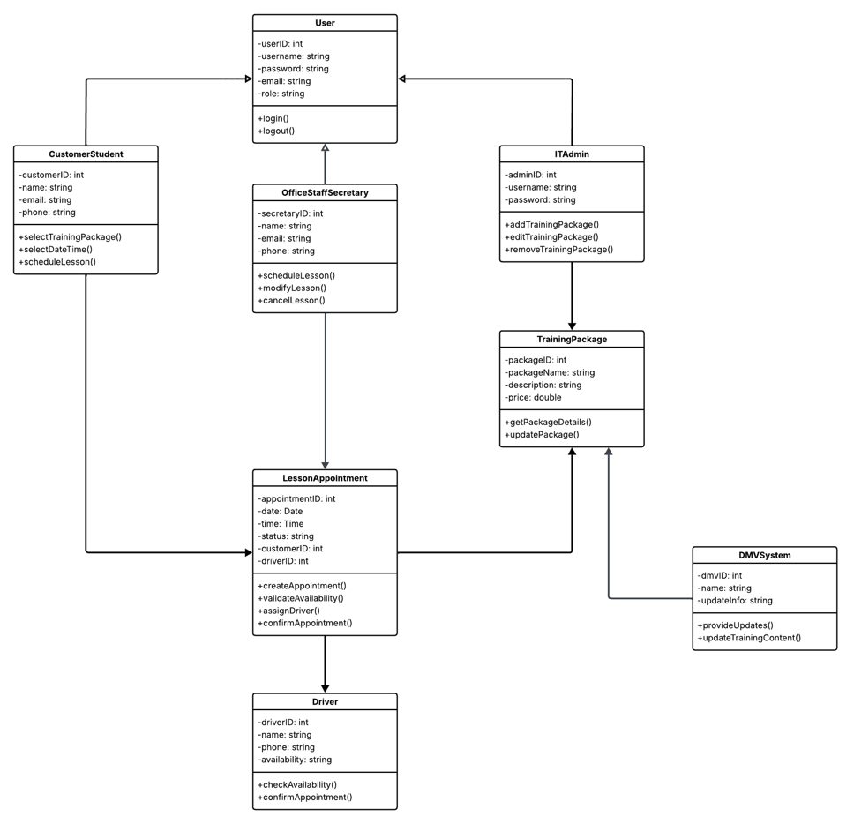

Technical Requirements

Hardware Requirements

The DriverPass system requires client-side hardware and cloud-based server hardware to support system operation. Users, including customers, office staff, drivers, and administrators will access the system using computers, tablets, or smartphones with internet connectivity. Because the system is cloud-based, primary processing and data storage will occur on cloud-hosted servers rather than local machines. These servers must provide sufficient processing power, memory, and storage to support user account management, lesson scheduling, training packages, and customer data storage.

Software Requirements

The DriverPass system requires software to support web-based system functionality, secure user access, and data storage. Users will access the system through standard web browsers such as but not limited to, Google Chrome, Microsoft Edge, or Safari. The server environment will require server operating system, web server software, and a database management system to store customer accounts, lesson reservations, training packages, and payment information. These software components support core system functions such as scheduling appointments, managing accounts, and storing customer and training data.
Tools Requirements

The system requires administrative and management tools to support ongoing system maintenance and operation. These tools include database management tools to maintain stored system data, system monitoring tools to ensure system availability and performance, and administrative tools that allow IT staff to manage user accounts, permissions, and password resets. These tools support system security, adaptability, and account management requirements.

Infrastructure Requirements

The DriverPass system requires cloud-based infrastructure and reliable internet connectivity to support system availability and remote access. Cloud hosting ensures that users can access the system from any location and that system data is securely stored and maintained. Secure authentication and controlled access measures are required to protect customer information and payment data. This infrastructure supports system accessibility, security, and continuous operation requirements defined in the system design.

